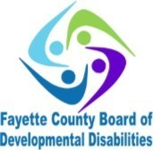

*“FCBDD empowering people to be the best version of themselves.”*

**1330 Robinson Rd. Washington Courthouse, OH 43160**

[**www.fayettedd.com**](http://www.fayettedd.com)

**740-335-7453 phone 740-335-2185 fax**

**FAYETTE COUNTY BOARD OF DEVELOPMENTAL DISABILITIES 2019 ANNUAL REPORT**

*Superintendent’s Message:*

Welcome to our Annual Report. Included in this report you will see highlights from our work throughout 2019. If I had to sum up my feelings about the past year, I would simply say, “I am proud.”

I am proud of the staff working for the FCBDD, I am proud of the growth I’ve seen in those in which we serve, and I am proud of the partnerships we have developed throughout our community.

I am also proud of the way all of us at FCBDD provide responsible financial stewardship over our local tax dollars. We do not take this responsibility lightly. County Boards of DD are intended to be the “payor of last resort”. Our staff spend a great deal of time assuring we investigate all avenues of resources before we allocate public tax dollars. We have become adept at “stretching the dollar” so to speak.

Last year our successes were many and we worked hard to see them thru. More individuals were employed throughout the community, the Dragons were champions and our little ones made strides in all things little ones do!

To our families and community partners, thank you for trusting us with your tax dollars, standing beside us and helping to celebrate all these successes.

Enjoy our report!

Deb Buccilla, Superintendent

**Abraham Lincoln — ‘You cannot help people permanently by doing for** them, **what they could and should do for themselves**.’

Special Olympics…

Dragons and a Successful Year….

The Fayette County Dragons participated in a variety of sports in 2019. Athletes were comprised of adults and students. These athletes participated in sports events that included: traditional basketball with a JV and Varsity team, bowling, track and field, cheerleading and flag football.

For the first time, ever, they competed in traditional softball and had a very successful season. There were **90** total athletes competing in at least one or more sports. The JV basketball team made it to the State Final 4 for the second year in a row and finished third. The Dragon’s flag football team once again traveled to University of Cincinnati’s, Nippert Stadium and, also Paul Brown Stadium home of the Cincinnati Bengals for the State flag football tournament. This tournament turned out to be a huge success as they once again brought home a State Championship for the second year in a row.

2019 was a wonderful year of fundraising which included the annual Dwight Turner Spaghetti Dinner and the annual Guns-N-Hoses fundraiser basketball game. We were also able to host the annual Dime-A-Dog night once again this year which was a great money maker for the organization in 2019.

Many of the athletes had the privilege of competing in skills invitationals this year, which included the football invitational held at the Woody Hayes Facility at The Ohio State University. The basketball skills competition was held at Ohio State’s Value City Arena, and the tennis invitational which was held in Cincinnati at the Lindner Tennis Center home of the Western & Southern Professional Tennis Open! It was a great year to be a Dragon and we are looking forward to another successful year in 2020! Our competitions are open to the public. Please join us! To stay up to date on the competitions, check out our website at [www.fayettedd.com](http://www.fayettedd.com) or our Facebook page.

**Early Intervention (EI) 2019**

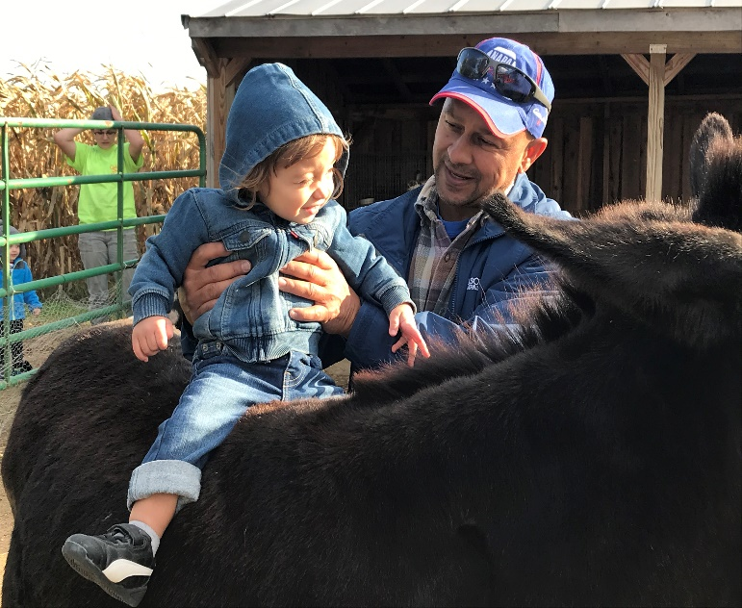*Why wait, evaluate* is the mantra. Getting help at a younger age can benefit a child through an entire lifespan. Everyday learning opportunities and routines guide how the Early Intervention Team works with children and families to enhance development. These services are provided in the child’s natural environment and are centered on the interests, strengths, and priorities of the child and family. Little ones from birth to three years old, can be referred for services in a variety of ways and reasons including a diagnosed medical condition or a suspected disability or delay. Two automatic diagnosis areas were added in July of 2019 those being infants diagnosed with NAS, Neonatal Abstinence Syndrome, as well as lead exposure. The infants and toddlers are assessed and evaluated for eligibility both to enter the program and as they transition into preschool. The Board of DD works collaboratively with many agencies, including the school districts to provide a continuance of service. In 2019, there were 71 children served by the EI team. The team consists of developmental specialists, a nurse, occupational and speech therapists and a contracted physical therapist. Our ongoing goal is to serve children, coach families, build confidence and competence. The FCBDD also holds the Part C service coordination grant for Fayette County and manages the Individual Family 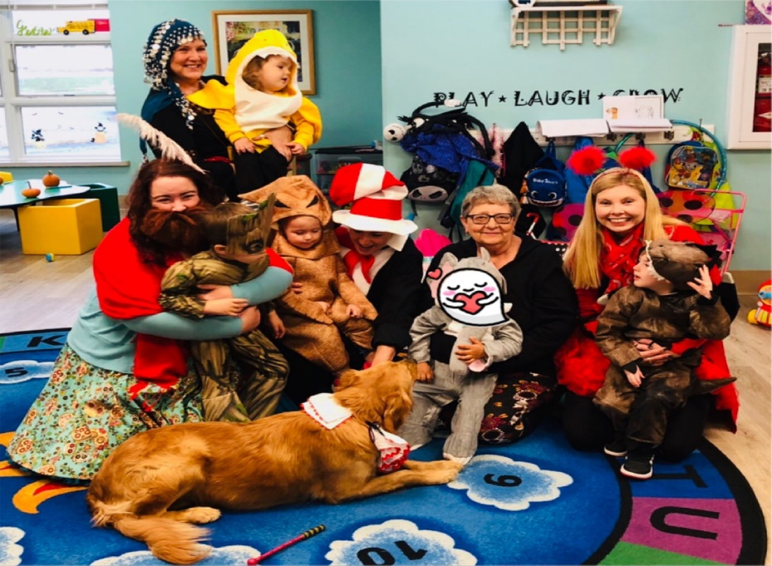Service Plans. Additional programs include aquatic therapy and certified PLAY therapy along with service from a certified newborn observation clinician (NBO). Weekly playgroups add social interaction with peers and the team as well as new and fun activities.

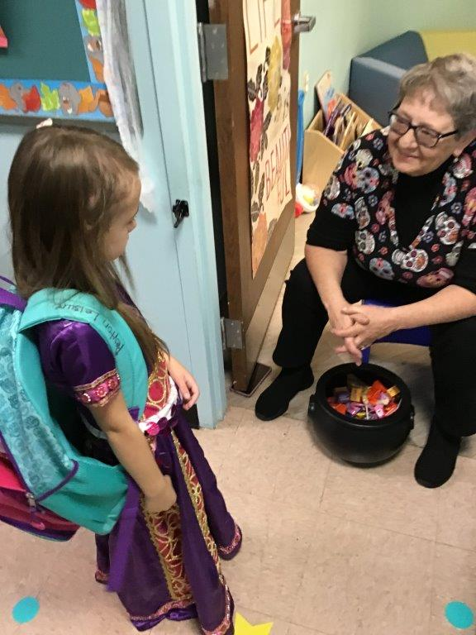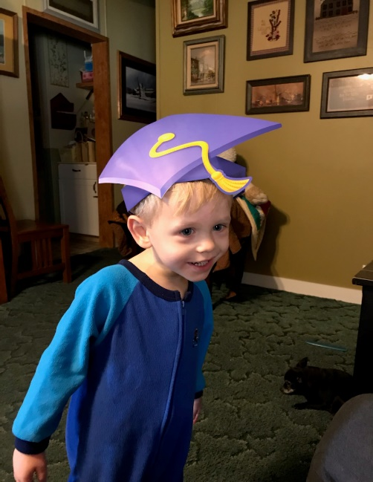

**Help Me Grow (HMG)**The FCBDD Help Me Grow home visiting program focuses on the early experiences of babies. A variety of early experiences is what shapes the brain for success in life. HMG serves families who have children that are prenatal to age three. It is a home visiting program that is voluntary and provides family support, education and advocacy for pregnant women and new parents. The service is offered in every county of the State of Ohio.

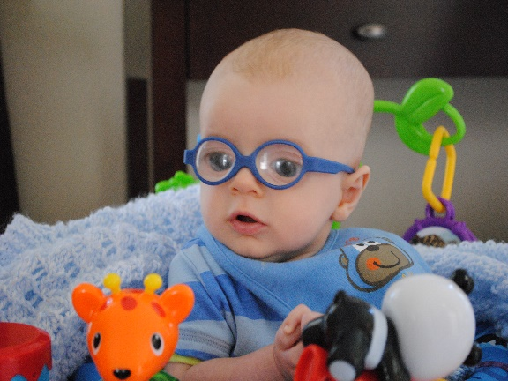

[This Photo](https://littlefoureyes.com/2010/10/22/your-stories-jacks-journey-with-infant-cataracts/) by Unknown Author is licensed under [CC BY-NC-ND](https://creativecommons.org/licenses/by-nc-nd/3.0/)

*HMG is funded thru the Ohio Department of Health and does not rely upon local tax dollars from FCBDD.*

**Community First Department 2019**

The Community First department continued to support and assist people with disabilities through work experiences, social activities, and self-advocacy. People with intellectual and developmental disabilities have become more empowered to be the very best version of themselves, becoming active and valued citizens within their community.

The Community First department and the Transportation department partnered with the Miami Trace Work Study classes to provide transportation to three volunteer work sites within Fayette County. At these volunteer work sites, 19 students, ages, 14-22, had the opportunity to develop or improve their work-related skills such as, inter-personal, self-direction, teamwork, timeliness, work-ethic and hygiene. Having these skills helps to increase their confidence and improve their employability outcome. The work study teams ended their year with a breakfast banquet, wrapping up their training with supervisors from their volunteer sites.

The 3rd annual 5-county Transition Expo. was held at the Good News Gathering in Hillsboro, Ohio. There were 25 vendors/businesses present that shared great tips on how to train for and apply for a new career. Fifteen of the eighteen school districts located in Adams, Brown, Clinton, Fayette, and Highland Counties participated in the event. Nearly 300 High School students with disabilities came dressed for success, prepared to meet local employers and education experts. The students also attended three learning sessions on: What Not to Say or Wear; Work Ethic; and Their Own Elevator Speech.

The adult Advocacy group, F.A.C.T. (Fayette Advocating Change Together) continued to meet monthly at Kroger to help empower people with self-determination, develop the confidence to speak up for themselves, gain skills to become leaders, and become active members of their community. This goal is reached through many opportunities provided through trainings, seminars and conferences. Eight adults attended a fire safety training at our local Fire Dept. with Fire Chief, Tim Downing. Nine adults completed a Basic First Aid refresher course with EMT, Philip Funk. Melissa Havens, Emergency Management Director, instructed nine of our adults on how to prepare for a disaster and shared a disaster kit that everyone should have in their home. 11 volunteer/members from the F.A.C.T group took turns to attend a 14-county regional advocacy meeting, held in Chillicothe, Ohio. A variety of trainings/topics were offered at the regional meetings. Two adult advocates attended a 3-day Project Stir Training, at Deer Creek, led by the Ohio Self Determination Association, focusing on Self-Advocacy and how to teach others to advocate for themselves.

Five adults attended the Ohio Provider’s Resource Association (OPRA) Spring Conference. The attendees had the opportunity to hear from the new Director of DODD, Jeff Davis. Director Davis shared legislative updates. EVV, Electronic Visit Verification systems were addressed, and everyone had the chance to ask questions and share their concerns about invasion of privacy.

Two adult advocates attended the DD Awareness and Advocacy Day at the State House in March. The month of March was National Developmental Disabilities Awareness Month. The theme was "Supports Matters.  Attendees had the opportunity to hear from Ohio Department of Development Disabilities' Director Jeff Davis, Director of Opportunities for Ohioans with Disabilities, Kevin Miller, Treasurer of State, Robert Sprague, and Stable account holder, Travis Dresbach. Each constituent was given the opportunity to meet with their legislators and advocate for issues that are concerning for themselves and other people with disabilities. Fayette County advocates shared their concerns with the Direct Care Workforce Crisis, and the continuing concern for the lack of transportation. This annual community and advocacy event, sponsored by OPRA and the Ohio DD Council, offered a great opportunity to meet legislators, fellow advocates and other self-advocates who are all working to make Ohio a better place for people with developmental disabilities.

The end of the year was wrapped up with the F.A.C.T. group partnering with the Community Action Center, for their Santa for Seniors project. Two of the F.A.C.T. members volunteered their time to help deliver Christmas baskets/gifts, (along with other community members), to approximately 70 people who were homebound within Fayette County.

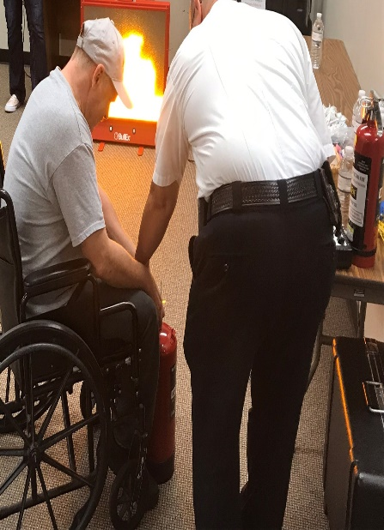 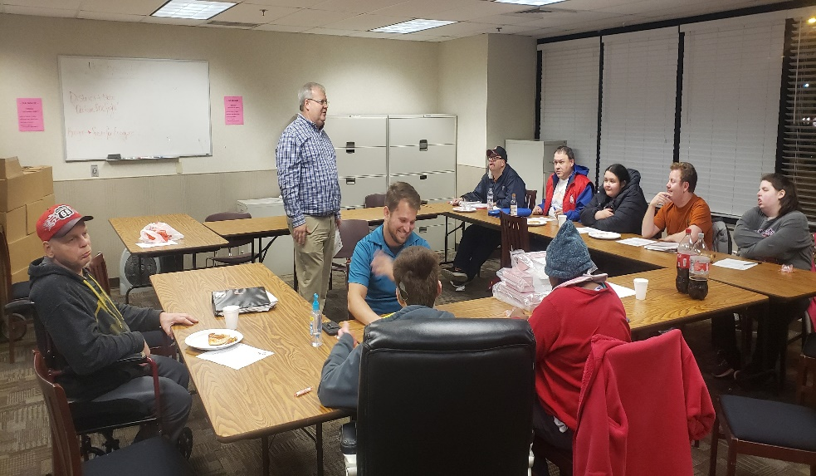

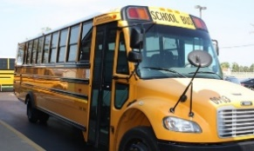INTERESTING FACT…

In Fayette County, the FCBDD buses travel 290 miles each day and transport 71 preschoolers.

**Operations Department**

Information Technology (IT) is an area that many small government agencies have been under attack by cyber criminals. Cyber-criminal attacks are known for steeling online data about individuals or businesses. FCBDD has been proactive in that we have increased our abilities to back-up data, increase storage on and off site and continued training for our staff to heighten awareness of potential cybercrime.

We have about 50 staff in FCBDD and over 75 devices that we maintain. Through training and increased security, we will continue efforts to protect the sensitive information that we use and store.

**Transportation Department**

We purchased our first new small preschool bus this year as we transition from the larger buses. The smaller buses are not as intimidating to first time bus riders and are designed for preschool students.



[This Photo](https://www.flickr.com/photos/rumblepress/11253544503) by Unknown Author is licensed under [CC BY-SA](https://creativecommons.org/licenses/by-sa/3.0/)

Fayette Progressive Preschool

“Where PLAYING is LEARNING, and LEARNING is FUN”

Four classrooms of students in half day classes, came to preschool in 2019. Our 5-Star Rated program is governed by the Ohio Department of Education and the FCBDD Board members.

105 students with and without special needs, are served Monday through Thursday each week during a calendar year. The teaching staff are all credentialed Intervention Specialists and our Teaching Assistants have obtained their Paraprofessional certificates from the Ohio Department of Education.

Our staff have participated in at least 20 hours of professional development over the past year in areas such as Positive Behavior Management, First Aid/CPR/AED, Early Childhood Development, Autism and Assessing Preschoolers.

In addition to the classroom, our students participate in physical activities in a gross motor room and our hallways; have sensory opportunities in a sensory room; enjoy recess in a large playground area and attend special events and field trips.

Community guests visit. The Carnegie Library is a regular visitor bringing books to read to the children every month.

Some of the most fun events this past year were activities with the parents: Easter Egg hunt, Pumpkin Science Night, the Zoo trip, the apple orchard trip, Trick-or-Treat, Trunk-or-Treat in the Kroger’s Parking lot, and when Santa made his annual visit.

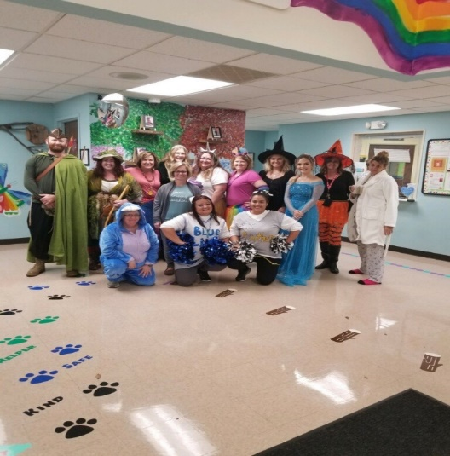 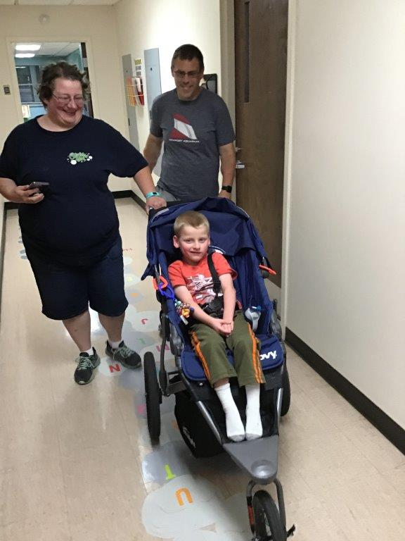 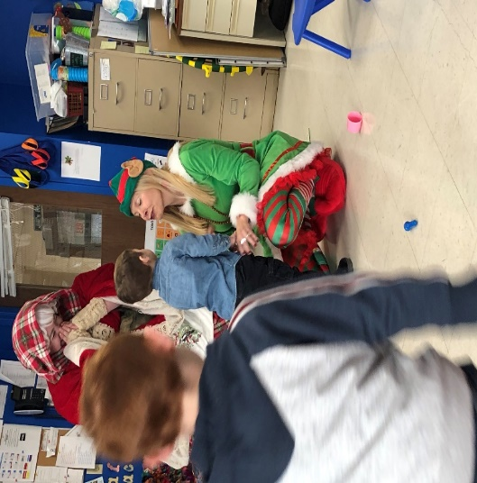

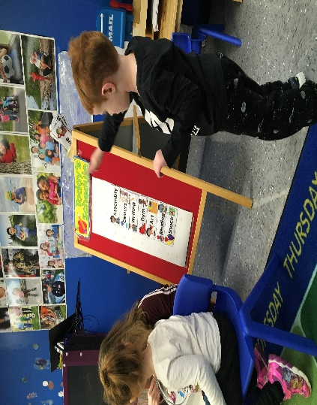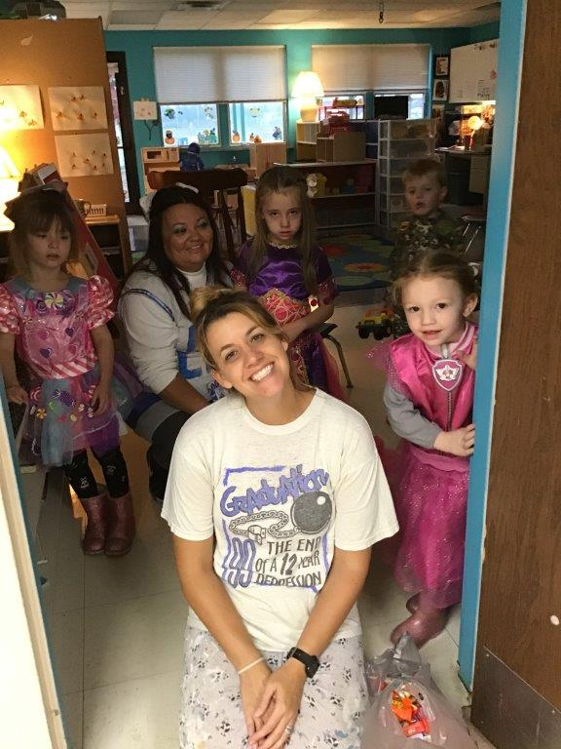Our services provide what a child’s needs require. We work with the local school districts to plan goals for our preschoolers to attain each year. They might work on speaking better, walking and even recognizing and managing their emotions better. Local and state tax dollars, as well as private payments, fund our programs to thoroughly prepare our little ones for Kindergarten.



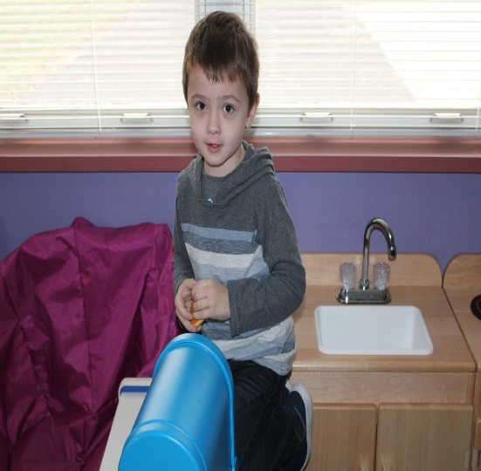*

*Service and Support Administration*

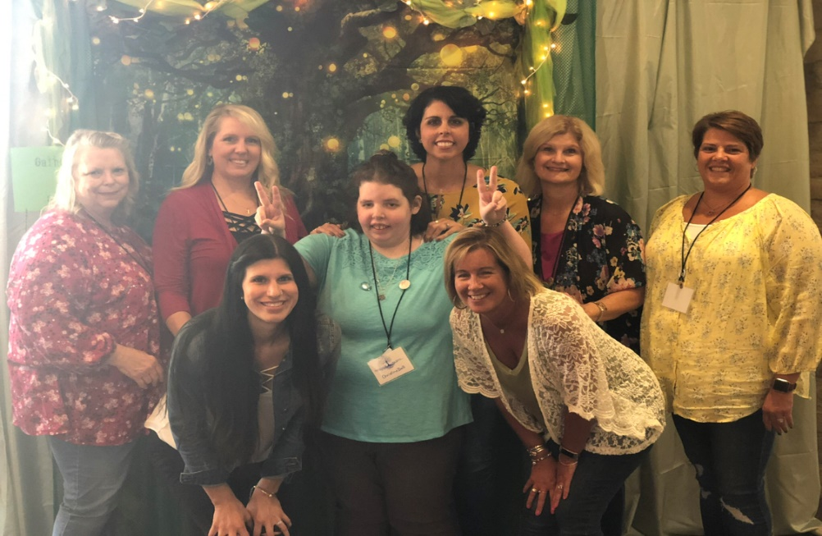

The focus of Service and Support Administration, who served 145 people in 2019, is to use person-centered practices to assist people in having meaningful lives. This is done by the development of outcome-based goals that is led by the person and accomplished through natural supports, community resources and paid supports, if needed. Service areas include:

**Intake and Eligibility** – Upon application, diagnosis verification is needed before proceeding to the assessment that determines eligibility.

**Employment** – With Ohio declared an “Employment First” state, we work with every person who is of employment age, to determine what their path of employment is. Once their employment goal is identified, we assist in coordinating the appropriate supports and training that is needed, including referrals to the Opportunities for Ohio with Disabilities (OOD) agency.

**Community inclusion –** As citizens of Fayette County, it is important that people are included in what our great community has to offer. Through the person-centered process, we assist people to live, work, and enjoy their community.

**Options for housing** – The Fayette County Board partners with the Fayette County Metropolitan Housing Authority to ensure affordable and quality housing for people. Currently, the Housing Authority owns 12 homes that were funded by the Ohio Department of Developmental Disabilities Capital Assistance Program. Along with other community resources, including the 811 Program, we assist people in finding the right home for them.

**Maximize alternative resources/revenue streams –** As required, once we have identified a person’s needs through a person-centered process, we look at all ways those needs can be met, including, natural supports, community resources or paid supports. In 2019, we also used resources from the Strong Families, Safe Communities Grant, through the Ohio Governor’s Office and the Remote Support and Technologies Grant from the Ohio Department of Developmental Disabilities.

**Waiting list -** In September of 2018, the Waiting List for Medicaid Waiver Services changed to include using a current needs assessment from the Ohio Department of Developmental Disabilities instead of a making requesting a Medicaid Waiver or to be on the waiting list. Through this assessment process, if unmet needs are identified, alternative services and resources must be considered before determining the need for a Medicaid Waiver. Those who were on the waiting list prior to the rule change are being notified, with assessments completed as requested.

**Trauma Informed Care Training –** With our own TIC trainer, Cheryl Binegar, we have been able to work with community agencies, schools, providers and families on training needs and with creative support development. Having this training allows for effective supports that promote resiliency and healing.

**Provider support and expansion –** To have quality services and supports, people with paid supports, need trained providers that can assist them in the areas they need help in. Providers help people in their homes, community, socializing, employment, just to name a few. The Fayette County Board continuously works with our existing providers for needed training and program development, along with outreach to new providers.



[This Photo](http://janjansen.guru/be-kind-to-others-because-everybody-need-a-helping-hands/) by Unknown Author is licensed under [CC BY-NC-ND](https://creativecommons.org/licenses/by-nc-nd/3.0/)

Served 145 people

Ages (3-17) 21 Ages (18 – 30) 50 Ages (31-50) 41 Ages (51+) 30

The Fayette County Board of DD works with people through a person-centered assessment process to determine if they have any unmet needs and how those needs can be met. The approach to meeting needs is identifying what resources are available through the following order:

**Natural Supports** – family members, relatives, neighbors or others in the community or organizations that serve the general public who provide voluntary supports. This also includes personal medical insurance and financial resources.

**Community Resources** – community programs, services and supports, that may be funded by the county board through local funds or other community agencies.

**Medicaid** – insurance payment for services or goods, including for home health and nursing services.

**Home and Community-Based Services Waiver** – payment for goods and services from certified providers.

**FUNDING FROM MANY RESOURCES**

In order to maximize alternative resources and revenue streams, the FCBDD seeks out funding and resources through various avenues. In 2019, we secured resources from the *Strong Families/Safe Communities Grant, through the Ohio Governor’s Office and the Remote Support and Technologies Grant from the Ohio Department of Developmental Disabilities.*

Services Provided in Fayette County

**

|  |  |  |  |
| --- | --- | --- | --- |
|  | 505 Total Served in Fayette County | | |
|  | 2019 |  |  |
| **Preschool** | 67 |  |  |
| **Special Olympics** | 90 |  |  |
| **Help Me Grow - Part C** | 101 |  |  |
| **Early Intervention** | 71 |  |  |
| **Transition Youth/Employment** | 19 |  |  |
| **Advocacy** | 12 |  |  |
| **SSA** | 145 |  |  |

2019 Fayette County Board of Developmental Disabilities

Board Members

Larry Mayer, President

Janelle Mead, Vice President

Alice Craig, Secretary

Mitchell Kirby

Cody Kirkpatrick

Mark Heiny

David Sanders

++++++++++++++++++++++++++++++++++++++++++++++++++++++++++++++++++++++++++++++++++++++++++++++++++

2019 FCBDD Administrative Staff

Debra Buccilla, Superintendent

Sherry Burns, Executive Administrative Assistant

Lori Moore, Business Director

Larry Gray, Operations Director

Renee Guess, SSA Director

Suzie Janasov, Early Childhood Services Director

Stacy Hazelton, Education and Public Relations Director

Jan Cobb, Nurse

Jennifer Goodwin, Investigative Agent

Betty Hodges, Community First/Transition Youth Director

++++++++++++++++++++++++++++++++++++++++++++++++++++++++++++++++++++++++++++++++++++++++++++++++++

**1330 Robinson Rd. Washington Courthouse, OH 43160**

[**www.fayettedd.com**](http://www.fayettedd.com)



[This Photo](http://educacionfisicaporproyectos.blogspot.com/2014/03/pagina-en-facebook.html) by Unknown Author is licensed under [CC BY-SA-NC](https://creativecommons.org/licenses/by-nc-sa/3.0/)

**740-335-7453 phone 740-335-2185 fax**

**TEAMWORK—DEDICATION—INTEGRITY--RESPECT**